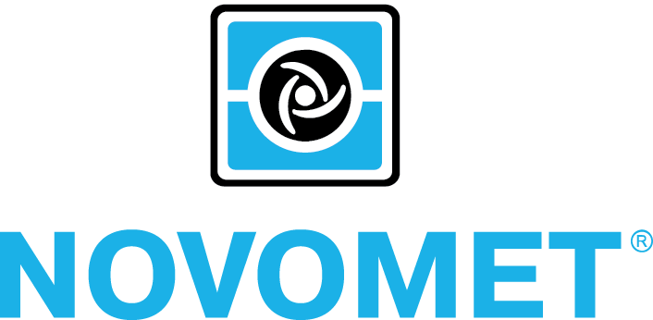­

We, NOVOMET-PERM JSC, DECLARE UNDER OUR RESPONSIBILITY that the product “Novomet Variable Speed Drive” including all presented models, which this declaration concerns, correspond to safety requirements and the harmlessness, stated in the EU Directives: 2014/35/EU – Electromagnetic Compatibility and 2014/30/ЕU – Low voltage Directive.

The product “Novomet Variable Speed Drive” including all presented models meet the requirements of Directives of EU under which it falls.

For fulfillment of safety requirements and the harmlessness, specified in the Directive 2014/30/ЕU and Directive 2014/35/EU following international standard of have been applied:

– EN 61439-1:2011 Low-voltage switchgear and controlgear assemblies - Part 1: General rules;

– EN 61000 series.

EU-type Certificate No. EM-006-18 26.01.2018, issued by the notified body Inspecta Estonia OÜ, Teaduspargi 8, 12618 Tallinn, Estonia, NB 1336.

|  |  |
| --- | --- |
| Manufacturer: | **NOVOMET-PERM JSC** |
| Legal Address: | 395 Shosse Kosmonavtov, Perm, 614065, Russia  Phone: +7 (342) 296-2756, 296-2759; E-mail: post@novomet.ru |
| Official representative in EU: | **Baltic CG SIA** |
| Legal Address: | Lubanas Str. 78, Riga, LV-1073, Latvia  Tel. +371 67795225, E-mail: baltic.commerce@gmail.com |
| Classification: |  |
| Type of product: | **Novomet Variable Speed Drive** |
| Brand: | **NVSD** |
| Model/type reference: | **NVSD 130KVA 380/480V 50/60HZ, NVSD 200KVA 380/480V 50/60HZ, NVSD 300KVA 380/480V 50/60HZ, NVSD 490KVA 380/480V 50/60HZ, NVSD 605KVA 380/480V 50/60HZ** |

EC DECLARATION OF CONFORMITY

_______________________________

***Date:***

***Position:***

***Name:***

***_____ _____ , 2018***

***General Director***

***Mr. Perelman O.M.***